ETHICS, RISK AND AI
NAME: MARGAM. AKSHAY RAJ
ITM 6000: FINFAL PROJECT IN ITM
PROFESSOR: Dr. MANI RAVINDRAN
UNIVERISTY: WEBSTER UNIVERSITY

Chapter 1
Situational Analysis
Integration of artificial intelligence (AI) into e-commerce has brought transformational changes across many industries; for instance, the clothing industry is termed as one of the dynamic and data-dependent fields. The research explores data privacy issues that arise with the adoption of AI techniques in clothing-based e-commerce sectors by assuming a fictional company, EFashion Clothing Co., to represent a technology-driven fashion brand. The situation analysed in this research paper has an influence on growing concerns about the ways that AI systems handle customer information in a rapidly growing and competitive retail environment (Cai, & Mardani, 2023).
Industry Overview. The clothing industry is highly sensitive to consumer preferences, fast changes in customer demands, and seasonal trends. Fictional organisation, EFashion is an e-commerce company specialising in trendy and affordable clothing for customers of all types. The clothing industry differentiates itself through its services, like personalised fashion experiences by using customer behaviour, real-time analytics, and style preferences. EFashion created a unique brand experience by integrating AI-generated fashion recommendations, managing dynamic inventories, and staying connected with customers across various digital platforms (Goti et al., 2023).
Culture and Competitive Environment. EFashion, which drives its clothing through AI, differentiates its brands from competitors through an agile and customer-centric culture. The technology culture of EFashion allowed it to stay ahead in aspects like inventory control and forecasting, but demanded organisation handle responsibilities like data ethics, customer trust, and transparency. Supporting automation has created a workspace at EFashion where decision-making is improved through AI algorithms. The “EFashion” clothing industry is managing its operations in a highly competitive environment since competitors compete with the industry not only in aspects like price and quality but also on quick delivery, personalised services, and brand loyalty. Additionally, small niche brands are emerging with ethical and transparent data approaches, which have a great influence on customer preferences (Ray, & Nayak, 2023). To survive in a competitive landscape, EFashion should spend on innovation as well as security frameworks that provide guidelines on managing customer information.
Issue. A central issue highlighted in this research paper is data privacy violations rising in the “EFashion clothing industry” due to the non-transparent use of AI-powered systems. EFashion during the extraction of different types of customer information to enhance customer experience through services. The data extraction poses threats to organisations because it crosses legal and ethical boundaries, as customers do not have knowledge of how collected data is processed, shared, and stored, resulting in customer dissatisfaction, regulatory non-compliance, and trust issues (Madanchian, 2024).
Several Factors Influenced the Selection of This Subject. Various factors that played an important role in selecting this specific subject include relevance, growing criminal attempts on personal data, and the opportunity for a unique brand story. E-commerce sectors are quick adopters of AI, which enables me to conduct this research and determine how to make EFashion timely and relevant in the exploration of data privacy and innovation in customer services. The clothing industry's efforts to collect customer information increase data breaches and theft issues if they do not have proper security measures. An increase in cybersecurity criminal attempts and technology sophistication in attack launching enabled me to focus on customer privacy through this research. Additionally, the fictional nature of the industry gives an opportunity to develop realistic scenarios; hence, focusing on the brand as well as customer trust will add value to the company and create a unique identity (Madanchian, 2024).
Premise
Adopting strong data privacy policies and user-centric controls in an AI-enabled e-commerce platform will help EFashion establish appropriate security for customer information, maintain compliance, and enhance customer trust while still supporting AI benefits for business growth.
Definitions
Definitions used in this paper are encryption, real-time dashboards, transparent data policies, artificial intelligence, user-centric controls, and opt-in or opt-out mechanisms.
The term encryption is defined as a process that transforms sensitive data into a coded format, which is accessed by individuals who have the proper decryption keys. From the perspective of e-commerce, encryption promises the security of financial and personal data both in transmission and storage.
“Real-time Dashboards” is termed as a digital interface that gives users quick access to updated data. AI-powered e-commerce applications need a dashboard that allows both customers and admins to keep track of their metrics, like account activity, order status, and personalised settings.
“User-centric controls” mean settings and features of the platform or application that give users complete control over how personal information is collected, used, stored, and exchanged. Examples of user-centric controls are getting user consent through consent forms, opt-in or opt-out choices, and applying privacy settings to respect user privacy and align with data privacy regulations.
“Transparent Data Policies” mean clear and accessible statements prepared by a company to explain how it collects, processes, stores, and shares customer data. The type of information includes data retention periods, user rights, security practices, and third-party sharing. Transparency ensures that users are informed and make professional choices using customer information (Madanchian, 2024).
“Artificial Intelligence” is a branch of computer science that lets machines perform tasks just like humans by learning from data and recognising patterns (Madanchian, 2024). This is a computer system that has the potential to learn from data, identify data patterns, and make decisions with minimal human intervention.
Opt-in or opt-out choices mean a consent mechanism where users are allowed to choose whether or not to extract and use their data by companies. Opt-in needs active user permission, and opt-out implies permission unless it is declined.
Limitations
Scope of Fictional Company. The study is about a fictional company, the lack of actual organisational and customer information influences on project, which limits the potential of validating gaps in existing organisational policies, and real-time scenarios of data breaches.
AI Risks are Neglected. The research just focused on common AI applications like behavioural tracking and predictive analytics, but failed to explore decision-making errors due to poor training models. During the process of researching data privacy risks that arise from AI integration, the potential issues, like algorithmic discrimination and adverse AI attacks, weren’t examined in detail.
Limited Interaction. Even online interviews are conducted to collect insights from experts, but do not include direct user feedback from industry customers or live tests on the AI tool to strengthen the value of practical findings.
Short Timeline. Another limitation is that, due to the short timeline, the study brought complexities in organising in-depth privacy research, like in-person interviews with AI and data privacy experts, and e-commerce practitioners.
Delimitations
Focus on AI Applications. In this study, AI-enabled systems features relevant to e-commerce, which are used most commonly, are examined, like recommendations, behavioural tracking, and predictive analytics. It does not consider advanced technologies like IoT and biometric data management in retail industries. In general, IoT plays an active role in monitoring customer behaviour, tracking inventory, and helping in functional and financial decisions (Leleko, & Chupryna, 2025).
The research focused on customer-related privacy and personalised services in e-commerce. It did not cover security related to suppliers, internal staff, and third-party data management.
Limited Regulatory Concepts. The research explored general privacy issues and does not include detailed information on international privacy approaches, like GDPR, and CCPA, as well as frameworks impact on the EFashion industry in AI implementation.
Change Management. Topics like company-wide privacy policies and compliance culture developments are just recommended, but are not examined deeply due to a short time period. Organising training programs on AI tools is important to ensure that employees at the organisation use tools effectively, but research didn’t recommend this strategy to EFashion Clothing.
No Comparison of AI Models: The Study didn’t compare different types of AI recommendation systems, like differential privacy and federated learning. The primary focus stayed on identifying issues lying in standard AI tools, specifically in customer data processing.
Applied Research Methodology
The research of the fictional company EFashion Clothing industry adopted a combination of secondary and a few primary research approaches. The aim of adopting these research methodologies is to gain comprehensive knowledge and understanding of the impact of AI on customer privacy and to adopt steps required for the mitigation of associated risks.
Primary Research Methodology & Justification. The primary research used to gain a comprehensive understanding of data flows, behaviours, and privacy challenges at EFashion clothing. Interviewing cybersecurity and AI experts, and e-commerce practitioners determined how AI systems interact with customer information, and highlight real-world risks along with preventive measures to be adopted by the firm. Moreover, this research methodology also helps to fill the gap between the practical and theoretical application of data privacy issues in the AI environment. Online interviews provide ethical and flexible ways to gather insights regarding customer data privacy without violating privacy (Wang et al., 2023).
Secondary Research Methodology & Justification. Using secondary research methodology, an in-depth review of existing literature, white papers, case studies, and journal articles was conducted to keep a strong focus on AI and security in e-commerce with evolving threats. Secondary research is considered to as the core methodology because of its high availability of sources, and up-to-date academic and industry literature. Reviewing all sources offered by secondary research methodology will help the EFashion Clothing Co. industry to understand threats and even shape ways of collecting and using personal data (Alasa et al., 2025).

Chapter 2
Primary Research Instrument
The central idea of using primary research is to get practical insights regarding AI influence and customer data privacy in EFashion Clothing Co. Using experts' insights and direct responses, primary research validates concerns identified in the industry. The expected outcome from using primary research is to collect informed insights and suggestions on implementing privacy tools, user-centric controls, ethical practices, and opt-in/opt-out mechanisms in the EFashion clothing industry (Chubb et al., 2021).
The mechanism used for the primary research is “Structured Online Interviews”. The tools used to conduct interviews are “Google Forms and Google Meet”
Another mechanism used to conduct primary research is a Survey. The tool used is SurveyMonkey.
Data Collection and Analysis Plan
Firstly, I use Google Forms to collect participants' information and complete registration. Next is conducting an interview, from which data is collected through Google Meet, focusing on real-time perspectives on customer privacy issues. In parallel, surveys were distributed among a few customers or friends close to me who are customers of the e-commerce industry; their responses will be helpful for me to understand e-commerce websites or application services for customers. Responses are analysed to identify common patterns, challenges, and best approaches supporting AI-driven customer data management. Findings will be helpful to validate the assumptions of the research and generate practical suggestions for EFashion Clothing Co. about their data privacy framework.
Ethical Considerations
While organising online interviews of primary research, the following ethical considerations are important because of topic sensitivity, like organisational security practices, data privacy of participants, and AI surveillance (Misza et al., 2023).
- Informing participants of the interview is one of the ethical considerations that must be conveyed to them about the purpose of conducting research, and obtaining their consent before participation.
- To maintain confidentiality, no identifiable information related to participants or affiliated organisations is collected or opened while presenting final reports.
- Questions must be designed in such a way that they do not include proprietary and classified information. Also, participants have the right to skip a question if it seems sensitive.
- It is also important to take measures to establish integrity, implement end-to-end encryption, and secure data handling protocols for data storage and exchange.
Interview and Survey Questions
Interview Questions
- What type of customer information is collected by service providers from e-commerce platforms?
- Define the role of AI in extracting and using customer data as a part of customer service.
- How do e-commerce applications store and protect customer data?
- Are customers informed by the company regarding how their data is being used?
- Explore some ways that how company can maintain transparency while enabling AI-based systems to use customer data.
- How can e-commerce platforms restore customer trust from data collection?
- Give some recommendations for companies to prevent data misuse and unauthorised access to e-commerce.
- What is your opinion about customer data privacy in the next 3-5 years?
- What type of laws and regulations do the companies follow to strengthen customer data privacy?
- Do you have any experience with ethical misuse by AI in e-commerce?
- Tell me what the biggest challenge companies face today is in managing customer privacy.
- Give a few common examples of privacy risks brought by AI-based recommendation systems.
Survey Questions
- How often do you shop from e-commerce applications or websites online?
- What type of information did you share with e-commerce websites?
- Do you have any awareness of how collected data is used by companies?
- In your shopping experience, did you ever see an option like Opt-in or opt-out data collection?
- Did you get personalised suggestions anytime from e-commerce websites?
- Have you read the privacy agreement or policy before filling in data on e-commerce platforms?
- Any experience of data breach or suspicious activity after sharing data online?
- What are your views on the statement “Personalised suggestions from e-commerce applications are helpful”?
Work Plan
The work plan for the project, solve security risks from AI-enabled e-commerce applications in the EFashion Clothing Co. industry.
- The first phase is “Identifying, inviting experts and target customers, and getting informed consent”. Key deliverables of this phase are finalising the questionnaire, preparing the interviewee list, and consent forms. On average, it takes 7 days to finish.
- “Data Collection” is the next phase, which focuses on conducting interviews with AI and cybersecurity experts, and e-commerce practitioners and recording their responses ethically and responsibly. After completion of the interview, distribute an online survey to selected customers or friends to gather their responses on e-commerce application services. This takes 20 days.
- Data analysis is the third phase, which comprises thematic analysis of interview insights and customer responses. It helps me to identify challenges, patterns, and best practices in e-commerce. Deliverables of this phase are preparing summary reports of findings collected. It consumes 7 days.
- Documenting findings is the next phase in which findings and issues are organised into structured sections and compared with the customer perspective. Deliverables of this phase are drafting the research paper section with findings, which consumes 6 days.
- After documenting findings, make sure to create actionable recommendations according to interview results and industry practices. A list of valid recommendations is deliverable in this phase; the time period is 7 days.
- Finally, compile full reports by combining expert knowledge and customer responses, recommendations from experts and an implementation plan. It takes 14 days.
On average, the project costs range between $30 and $50, depending tools or components used, including internet, interview tools, documentation, and analysis tools.
Chapter 3- Research Findings and Analysis
Chapter 3 provides key findings and insights from both primary and secondary research results related to the EFashion Clothing Co. industry. Data is collected from structured interviews with experts and surveys with e-commerce users.
Secondary Research Findings
Secondary research was conducted by using journal articles, industrial reports, white papers, and case studies, concentrating on AI integration into e-commerce. The sources used place strong emphasis on customer data privacy, security issues, and trust.
AI Personalised Services vs Data Privacy Issues
Famous e-commerce platforms like Shopify and Amazon use AI models to generate a personalised experience for customers. These platforms use AI models to analyse user behaviour, previous purchase information, and search history to generate suggestions regarding relevant products that meet customer tastes. The personalised services raise privacy issues, specifically due to users' lack of awareness of the ways the companies opt to use customer information, along with details of how the data is used (Teepapal, 2025).
Based on the above findings, EFashion Clothing Co must balance personalisation through data use policies. Getting informed user consent and transparency are crucial factors for the industry when it uses recommendation systems and behavioural tracking in customer services (Teepapal, 2025).
Lack of Transparent Approaches
Many customers worry about purchasing products at a store when they do not get proper information about how their data is used by the AI systems of e-commerce. However, unclear privacy policies and failure to provide clear opt-in and opt-out choices increase mistrust issues (Balasubramaniam et al., 2023).
Reviewing various secondary sources highlighted the importance of user-friendly data policies at e-commerce platforms. EFashion Clothing Co., by adopting clear and user-friendly data policies, lets users know how long the platforms store data, whether the data is shared with third parties or not, and how the firm controls the data (Balasubramaniam et al., 2023).
Data Governance
Integration of AI into e-commerce without a strong data governance approach results in facing vulnerabilities and threats like data leakage, ethical misuse, and unauthorised access. Researchers advocated for deploying ethical principles into AI design and deployment for accountability, fairness, and transparency.
Thus, it is essential for Efasion E-commerce to implement data governance policies and ensure accountability against data security crimes, create an internal audit system to monitor e-commerce transactions, and define ownership over AI decisions (Teepapal, 2025).
Impact of AI on Customer Behaviour
Using AI, retailers are enabled to make accurate predictions about seasonal trends, inventory management, and organise services tailored to the user experience. Secondary research sources revealed fashion recommendations in such a way as to increase customer engagement and repeat purchases, but also maximised concerns like profiling and surveillance (Teepapal, 2025).
Even though AI boosts engagement rates, Efashion should avoid depending heavily on intrusive surveillance because it makes the users uncomfortable. The key features important to boost engagement rates with customers are voluntary participation and user-centric design (Teepapal, 2025).
AI in Decision-Making
The researcher explored the role of AI in accelerating decision-making in the online retail environment. Real-time dashboard is one of the features of AI models that helps e-commerce platforms for various purposes like promotions, inventory updates, and updating customer data instantly. The quick decision-making capabilities of AI should not compromise security protocols (Teepapal, 2025). Growing concerns related to bias and ethical issues arise from AI-related customer profiling revealed from secondary findings. For example, poorly trained algorithms may discriminate against certain customer segments, specifically in fashion retail, where recommendations generated have an influence on the trained data.
Based on the above analysis, it is clear that Efashion AI models must be auditable, as logs must be maintained to keep track of AI decisions, specifically during contexts when customer data is involved.
Influence of Regulations in AI Integration
In fashion products, ethics and sustainability are important factors, specifically under regulatory pressure, which is achieved through following the CCPA and GDPR. Companies are neglecting these approaches, which have increased reputational loss and penalties for security crimes (Das, 2024). Regulations providing strong privacy protections in the US, but companies lack data laws.
Even though companies are fictions, it is essential to align data approaches with real-time frameworks like GDPR and CCPA to increase customer satisfaction rates (Das, 2024). EFashion Clothing Co. is operating globally; hence, it should consider regulations to protect customers globally and avoid experiencing legal issues.
Challenges Rise Due to Algorithmic Bias
Training AI systems or models on incomplete datasets and biased data produces discriminatory results. For instance, AI-based fashion suggestions might neglect diverse body or demographic groups unintentionally (Lee et al., 2019).
It is essential in the case of the fashion industry, review and retain AI models using representatives to maintain fairness and solve the reputational damage issue (Lee et al., 2019).
Secondary research findings demonstrated an understanding of AI in the EFashion industry; AI plays a significant role in e-commerce platforms in improving operational efficiency and boosting customer engagement rates. Secondary research has provided an opportunity to validate the findings extracted through primary research by providing sources that convey challenges in customer data management.
Application of Secondary Research to EFashion Clothing Co.
Using secondary research findings, the fashion industry recognised the measures to be followed in customer data management.
- Using explainable AI systems that provide the customers with information stating that how platforms generate recommendations.
- Draft clear and accessible data privacy policies for transparency.
- Privacy control dashboards and opt-in/opt-out choices are embedded into e-commerce platforms.
- Audit the AI models periodically to ensure fairness.
- Stay aligned with GDPR policies to meet global security standards and give the customer control over their personal information.
Secondary research mechanisms consider readily available information developed by other researchers, hence reducing the necessity for expensive and time-consuming data extraction or collection mechanisms. With the help of secondary research methods, I quickly accessed valuable content without demanding surveys and interviews (Teepapal, 2025).
Secondary sources developed a theoretical framework and identified gaps in existing research, which set up stage to organise primary investigation. Before organising primary research, using secondary research offered an understanding of the impact of AI in fashion revealed common privacy challenges.
The secondary sources have reinforced that EFashion must be paired with privacy measures to maximise customer experience and trust. The privacy measures not only enhance customer trust but also prepare the company for future regulatory compliance and survive in the AI-driven space (Teepapal, 2025).
Primary Research Findings-Survey
Primary research was conducted using structured interviews and online surveys. Primary research processes generated firsthand insights regarding the research topic within the e-commerce industry. Selected participants are interviewed through Google Meet and a Phone call. In parallel, a survey was conducted using the SurveyMonkey tool to gather user experience regarding data exchange on e-commerce platforms.
Conducted a survey with 10 e-commerce users (close friends and family).
Appendix A shows details of friends to whom the survey is conducted. Survey responses are attached, which were exported as a link.
Primary Research Results-Interview
Appendix B shows details of participants who are part of the interview.
Responses are presented below Appendix B.

References
Alasa, D., Hossain, D., Jiyane, G., Sarwer, M., & Saha, T. (2025). AI-Driven Personalisation in E-Commerce: The Case of Amazon and Shopify’s Impact on Customer Behaviour. https://www.scirp.org/journal/paperinformation?paperid=141154
Aldoseri, A., Khalifa, K., & Hamouda, A. (2023). Re-Thinking Data Strategy and Integration for Artificial Intelligence: Concepts, Opportunities, and Challenges. https://www.mdpi.com/2076-3417/13/12/7082
Balasubramaniam, N., Kauppinen, M., Rannisto, A., Hiekkanen, K., & Kujala, S. (2023). Transparency and Explainability of AI systems: From Ethical guidelines to Requirements.
https://www.sciencedirect.com/science/article/pii/S0950584923000514
Cai, H., & Mardani, A. (2023). Research on the Impact of Consumer Privacy and Intelligent Personalisation Technology on Purchase Resistance. https://www.sciencedirect.com/science/article/abs/pii/S0148296323001698?utm_source.com
Chubb, J., Cowling, P., & Reed, D. (2021). Speeding Up to Keep Up: Exploring the Use of AI in the Research Process. https://pmc.ncbi.nlm.nih.gov/articles/PMC8516568/
Das, U. (2024). AI-Powered Customer Behaviour in E-Commerce. https://multiarticlesjournal.com/uploads/articles/IJCRM-2024-3-4-1.pdf
Goti, A., Lomas, L., Almeida, A., Puerta, J., & Ipina, D. (2023). Artificial Intelligence in Business-to-Customer Fashion Retail. https://www.mdpi.com/2227-7390/11/13/2943
Lee, N.T., Resnick, P., & Barton, G. (2019). Algorithmic Bias Detection and Mitigation: Best Practices and Policies to Reduce Customer Harms. https://www.brookings.edu/articles/algorithmic-bias-detection-and-mitigation-best-practices-and-policies-to-reduce-consumer-harms/
Leleko, S., & Chupryna, R. (2025). AI and IoT: A New Era of Technological Integration. https://spd.tech/artificial-intelligence/ai-and-iot-a-new-era-of-technological-integration/
Madanchian, M. (2024). The Impact of Artificial Intelligence Marketing on E-commerce Sales. https://www.mdpi.com/2079-8954/12/10/429
Misza, H., Bellalem, F., & Mirza, C. (2023). Ethical Considerations in Qualitative Research: Summary Guidelines for Novice Social Science Researchers. https://www.researchgate.net/publication/370838199_Ethical_Considerations_in_Qualitative_Research_Summary_Guidelines_for_Novice_Social_Science_Researchers
Ray, S., & Nayak, L. (2023). Marketing Sustainable Fashion: Trends and Future Directions. https://www.mdpi.com/2071-1050/15/7/6202
Teepapal, T. (2025). AI-Driven Personalisation: Unravelling Customer Perceptions in Social Media Engagement. https://www.sciencedirect.com/science/article/abs/pii/S0747563224004175
Wang, C., Ahmad, S., Ayassrah, A., Awwad, E., Irshad, M., Ali, Y., Razgan, M., Khan, Y., & Han, H. (2023). An Empirical Evaluation of Technology Acceptance Model for Artificial Intelligence in E-Commerce. https://www.sciencedirect.com/science/article/pii/S2405844023055573

Appendix-A Survey Results
Name of Participant | Email | Distribution
Vaishnav Raj | rajv@gmail.com | email
Harika Patro | harikap198@gmail.com | Whats’app
Lavanya Jagillam | ljagillam256@gmailcom | email
Tejaswini Peru | tejup199@gmail.com | Email
Udhay Parsa | uparsa@gmail.com | Social media
Srija Karuva | skaruva009@gmail.com | Email
Abhisek Pawar | abhip@gmail.com | Whats’app
Sravan Kumar | skumar168@gmail.com | email
Sai Vikhas | svikhas178@gmail.com | Email
Prasanth Varma | pvarma@gmail.com | email
https://www.surveymonkey.com/r/PPQRNWX

The above forms are created to collect customer views who are availing services from the e-commerce industry.
Response Link

https://www.surveymonkey.com/results/SM-id_2BpwsNdtsIUahTxFqxN2g_3D_3D/

Survey Results
Link to Survey:
https://www.surveymonkey.com/results/SM-id_2BpwsNdtsIUahTxFqxN2g_3D_3D/

Please find the Screenshots of survey results below:
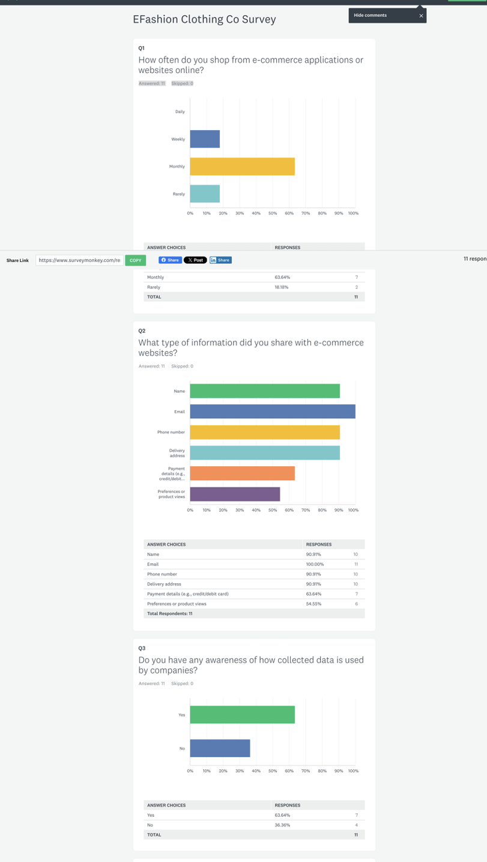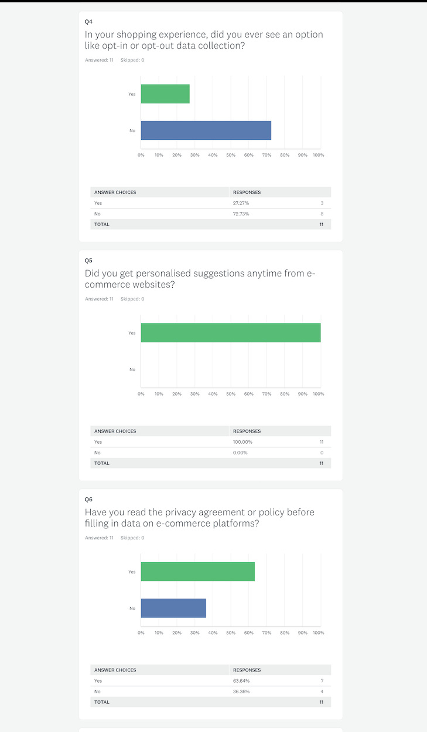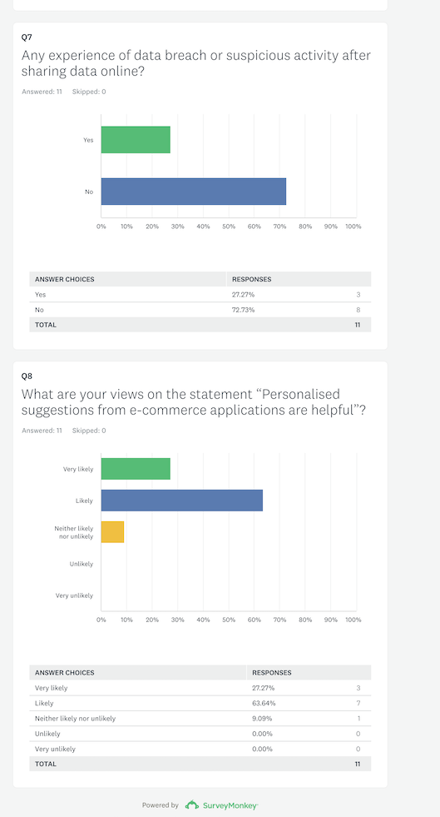

Appendix-B Interview Results
S.No | Name & Designation | Company Name | Email Address | Mode of Interview
1 | Kavya Mehta (AI Analyst) | Innovax Solutions | kavyamehta@innovax.com | Google Meet
2 | Arjun Shetty (Pursuing MBA in Cybersecurity) | Student at MLR Institute | arjunshetty@gmail.com | On-call
3 | Roshan (Product manager at e-commerce) | StyleCart Private Limited | roshan@stylecartpvt.com | Google meet

AI Analyst Response
1. What type of customer information is collected by service providers from e-commerce platforms?
Response: The Type of customer information collected includes time spent by the customer in using the website or application, search queries, click-streams, and personal information, including name, email and purchase history
2. Define the role of AI in extracting and using customer data as a part of customer service.
Response: AI analyses customer data patterns to generate personalised suggestions and forecast demand.
3. How do e-commerce applications store and protect customer data?
Response: Most e-commerce platforms use cloud computing options like encryption and train AI models based on pseudonymized data to minimise the attack surface. In general, data is stored in containers using access controls.
4. Are customers informed by the company regarding how their data is being used?
Response: Yes, but use lengthy privacy policies that make the user skip. To maintain transparency, an attractive dashboard and short summaries are required to meet the customer's understanding level.
5. Explore some ways that how company can maintain transparency while enabling AI-based systems to use customer data.
Response: Maintain transparency, need proper information about AI tools, generate automated notifications while processing data of new users, and display a summary of data usage about dashboards.
6. How can e-commerce platforms restore customer trust from data collection?
Response E-commerce platforms restore customer trust by sharing data like better efforts and faster services so that they gain complete visibility on how decisions are made.
7. Give some recommendations for companies to prevent data misuse and unauthorised access to e-commerce.
Response: Companies can prevent data misuse and unauthorised access to e-commerce platforms through the use of differential privacy approaches, running bias detection tools, and limiting access to training datasets while running AI models.
8. What is your opinion about customer data privacy in the next 3-5 years?
Response: In the next 3-5 years, there might be a chance of improvements like strict rules on global regulations and industry-wide recommendations for privacy by design regarding AI tools. Furthermore, AI need more justifications for data needs.
9. What type of laws and regulations do the companies follow to strengthen customer data privacy?
Laws and regulations followed by the company to strengthen customer data privacy include CCPA, GDPR, and internal AI ethics, aligning with evolving data laws.
10. Do you have any experience with ethical misuse by AI in e-commerce?
Response: Yes, I have experience with ethical misuse due to AI in e-commerce, as AI models cross-sell sensitive information like medical data, which has raised internal concerns.
11. Tell me what the biggest challenge companies face today is in managing customer privacy.
Response: one of the biggest challenges that firms are experiencing today while managing customer data privacy is to meet personalised needs along with privacy. The users in recent days are aware of privacy, hence expecting services that better tailor to privacy.
12. Give a few common examples of privacy risks brought by AI-based recommendation systems.
Response: A few examples of privacy risks brought by AI-based personalised systems include inference attacks that lead to sensitive exposure, and keep track of users across multiple e-commerce platforms without consent.
Response of a Student Pursuing MBA in Cybersecurity
1. What type of customer information is collected by service providers from e-commerce platforms?
Response: A Cybersecurity specialist responded by browsing history, personal identity data, transaction details, and metadata of the device, like browser version and IP address.
2. Define the role of AI in extracting and using customer data as a part of customer service.
Response: AI is extracting and using customer data in customer service is fraud detection, and behaviour monitoring. But AI capabilities have brought challenges from the attack surface through large data processing pipelines.
3. How do e-commerce applications store and protect customer data?
Response: E-commerce platforms usually store and protect customer information via secure servers, which are enabled with firewalls, identity access management, and firewall technologies. However, backup mechanisms are tested regularly and stored in secure zones.
4. Are customers informed by the company regarding how their data is being used?
Response: Not always are customers informed. The privacy policies and consent mechanisms are sometimes misleading and hidden.
5. Explore some ways that how company can maintain transparency while enabling AI-based systems to use customer data.
Response: Firms maintain transparency while using customer data in AI-enabled systems lies in implementing audit logs, maintaining proactive communication, and providing all customers with a history of data usage via application alerts.
6. How can e-commerce platforms restore customer trust from data collection?
Response: E-commerce platforms gain customer trust in data collection due to the implementation of strong breach disclosure policies, regular updates about system security and third-party certifications.
7. Give some recommendations for companies to prevent data misuse and unauthorised access to e-commerce.
Response: Some of the recommendations to prevent data misuse and unauthorised access to e-commerce platforms include organising penetration tests regularly, strengthening multi-factor authentication, auditing third-party data access, and encrypting AI models.
8. What is your opinion about customer data privacy in the next 3-5 years?
Response: In the coming years, AI systems will be accountable just as humans. Also, cybersecurity roles and responsibilities will shift toward AI governance, and the zero-trust architecture strategy will become standard.
9. What type of laws and regulations do the companies follow to strengthen customer data privacy?
Response: Laws and regulations help companies to improve customer data privacy, including the California Consumer Privacy Act, the General Data Protection Regulation, and also ISO 27001 standards.
10. Do you have any experience with ethical misuse by AI in e-commerce?
Response: Yes, I see ethical misuse of AI in e-commerce when location information collected through a shopping website is sold to an advertiser.
11. Tell me what the biggest challenge companies face today is in managing customer privacy.
Response: The biggest challenge companies face in managing customer privacy is uncontrolled third-party application programming interface. Most security breaches strike the organisation from vendors due to weak security.
12. Give a few common examples of privacy risks brought by AI-based recommendation systems.
Response: Example privacy risks from AI-based recommendation systems are data poisoning and storing a huge amount of data for future analysis without a specific use.
Response of Product Manager E-Commerce
- What type of customer information is collected by service providers from e-commerce platforms?
Response: Service providers obtain from e-commerce platforms different forms of customer personal information, such as name, email address, contact number, and shipping details. They also collect data such as order history, saved items, and user preferences to increase the shopping experience. A safe and encrypted payment gateway, in some cases, is the source of the payment method that is collected.
- Define the role of AI in extracting and using customer data as a part of customer service.
Response: Artificial Intelligence is a major factor in dealing with huge customer data to optimise service efficiency. The technology enables one-on-one customer experience through preference recognition and future behaviour forecasting. Besides, Al is the source of loyalty schemes and detects the situations that are the indicators of customer churn, enabling the timely support.
- How do e-commerce applications store and protect customer data?
Response: E-commerce applications collect customers' data and save it on a safe server that follows local and international data security rules. They usually use SaaS-based CRM systems and analytics tools that come with encryption designed for particularly confidential information. Access is secured through secure login protocols, and only authorised personnel can have access to or manage customer records.
- Are customers informed by the company regarding how their data is being used?
Response: Customers are usually made aware of the data usage by privacy policies that are available during registration and purchase transactions. These policies specify how personal information is gathered, secured, and utilised. However, there are platforms that might have to improve by making such information more visible and clearer in order to allow customers to be more informed and give their consent.
- Explore some ways that how company can maintain transparency while enabling AI-based systems to use customer data.
Response: To ensure that the trust is maintained with AI-managed systems, organisations need to offer simple explanations of how data is used during the customer's onboarding. It is also important that customers are given the option to control their preferences through clear opt-out options. Easy one-click actions for data deletion or improvement support user control, which in turn encourages moral treatment of data.
- How can e-commerce platforms restore customer trust from data collection?
Response: E-commerce platforms can recover customer trust if they are open during a data breach event and also clearly define the incident to the customers. A sign of goodwill in the form of store credits or discounts acts as a token of acknowledgement and empathy. Customers are also more likely to trust the platform if it demonstrates the implementation of better security measures to protect the data.
- Give some recommendations for companies to prevent data misuse and unauthorised access to e-commerce.
Response: Companies may reduce the chances of data misuse if they train their employees about proper data handling and implement access rules that are strictly observed. Limiting the customer information to what is necessary reduces unnecessary risk. Using short data retention times and regular checking ensures that the data management system is secure and complies with the requirements.
- What is your opinion about customer data privacy in the next 3-5 years?
Response: Data privacy is a top concern equally for consumers and businesses within the next 3-5 years. Users can look for solutions that will enable them to achieve the highest level of clarity and control over their data. So, organisations in the coming years must implement privacy strategies that are not only open and flexible but also meet their customers' needs to gain their trust.
- What type of laws and regulations do the companies follow to strengthen customer data privacy?
Response: Companies should follow data protection laws such as the General Data Protection Regulation (GDPR) for customers in the European Union. For example, in India, firms are moving towards compliance by following the Digital Personal Data Protection (DPDP) Act. By following these rules, corporate compliance becomes an important aspect of policies. Such legal systems provide for the responsible handling of data and create trust with customers.
- Do you have any experience with ethical misuse by AI in e-commerce?
Response: Earlier, a campaign was organised that used AI-operated analytics to classify users by age for targeted publicity. However, this led to an unexpected negative response. Its purpose was to change the proposals, but the method created concerns about the fairness and bias of some people. The situation highlighted the importance of a moral investigation into the AI-based marketing strategies.
- Tell me what the biggest challenge companies face today is in managing customer privacy.
Response: One of the biggest challenges that organisations encounter in customer privacy management is dealing with the public perception that users' actions are repeatedly under surveillance. Such an idea may lead to distrust without any mistake. However, the responsible utilisation of AI functions along with an honest response is critical to turn this negative impression into a positive one and regain customer trust.
- Give a few common examples of privacy risks brought by AI-based recommendation systems.
Response: AI-powered recommendation systems have the potential to violate privacy in the form of user tracking and tagging, which may not be done without the users' clear consent. The data may be distributed to other parties that run ads, and this may be the case even if users are not entirely informed. Besides that, hyper-personalised retargeting can become so unwanted that it makes customers uneasy about the way their data is handled.

